Using the EwE uncertainty sampler
EcoSampler is a utility for Ecopath with Ecosim that records and runs alternate balanced Ecopath parameter sets for a model to test parameter uncertainty. Each alternate balanced model is referred to as a ‘sample’ within the EcoSampler documentation.

User Interface
EcoSample is launched by choosing “Main menu > Ecopath > Record balanced models from Monte Carlo”.
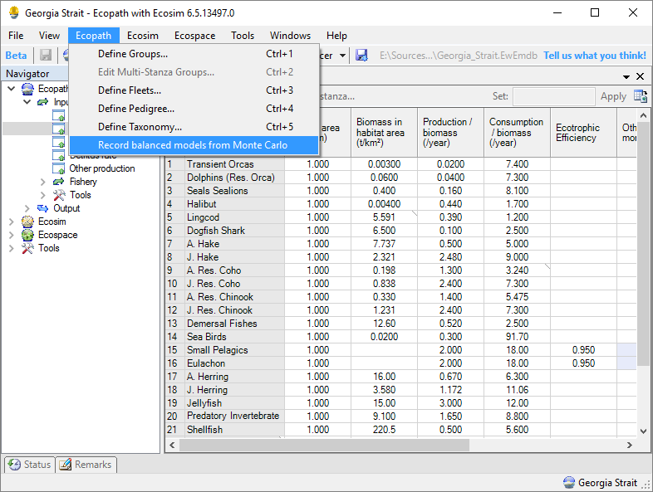
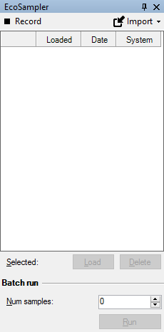
The EcoSampler User Interface offers the following elements:
1
2
3
4
1: Main toolbar, containing:
A record button to start or stop recording samples. A sample is recorded when Monte Carlo finds a balanced model, and is stored within the EwE model database.
Import facilities to import samples from other EwE models.
2: List of samples, showing, for each sample, a sequential number, the data and computer system the sample was recorded on, and whether a sample is currently loaded in the EwE user interface.
3: Controls to load or delete selected samples.
4: Batch run control panel that loads and runs a selected number of samples through EwE.

Recording samples
When activated, EcoSampler records alternate mass-balanced models generated by the EwE Monte Carlo routines. Samples are stored within the EwE model file.
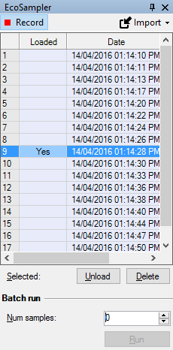
To activate EcoSampler recording, make sure the “Record” button is pressed. The record button is red when active, and black when inactive.

Managing samples
EcoSampler offers the possibility to load a generated sample in the EwE user interface to assess its validity. This will load the alternate parameter set as computed by Monte Carlo into the Ecopath input parameters, where they can be used to run any EwE module.
The EcoSampler user interface indicates which sample is loaded, and offers the ability to restore the original EwE parameter set. Note that the original model parameter set cannot be overwritten with values from a loaded sample; EwE will restore the original parameter set when a user clicks ‘Save’.
Users can delete samples that provide unrealistic alternate models, and can enter a rating to express confidence in a sample on a scale from 1 to 5. By default, samples are unrated when recorded, with a rating value of 0.

Importing samples
Especially when perturbing the diet composition matrix it may take the Monte Carlo routine a long time to find alternate models. Running multiple instance of EwE to record samples in parallel on different computers - or on the same computer - will greatly speed up the recording process. You can use the ‘Import samples’ functionality to import samples stored in another model database to bring all samples together.
Note that EcoSampler will only import samples between models with identical Ecopath parameterizations (see also sample validity, below).

Sample validity
Samples are alternate mass-balanced configurations for a given Ecopath model. If the Ecopath parameter input parameters are changed and these changes are saved, stored samples become invalid and will be deleted from the model file.

Running samples

